1. Launch EC2 Instance
Steps
- Login to AWS Console.
- Navigate to EC2.
- Click Launch Instance.
- Select Amazon Linux AMI.
- Choose t3.micro/t2.micro.
- Select/Create a Key Pair.
- Configure Security Group.
Security Group Ports
Port | Purpose
22 | SSH
80 | Nginx
8080 | Jenkins
8081 | Apache HTTP Server
8082 | Apache Tomcat
Launch the instance.
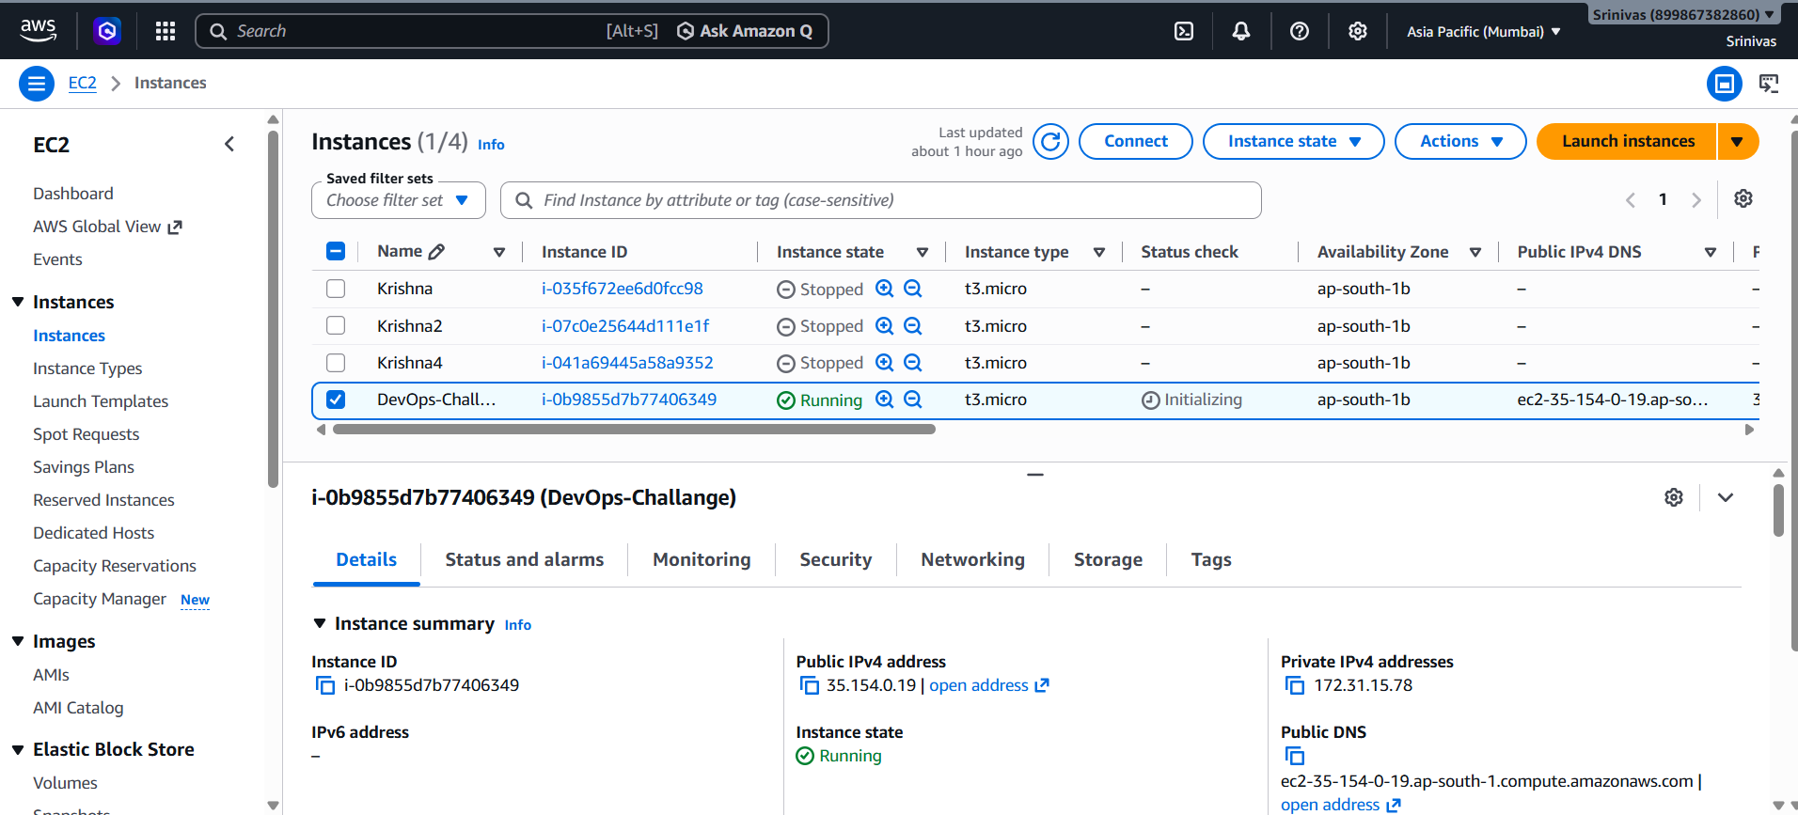

2. Update the Server
sudo yum update -y
Verify OS
cat /etc/os-release
3. Install Docker
Install
Amazon Linux 2023
sudo dnf install docker -y
Enable Docker
sudo systemctl enable docker
Start Docker
sudo systemctl start docker
Check Status
sudo systemctl status docker
Verify
docker --version
sudo docker ps

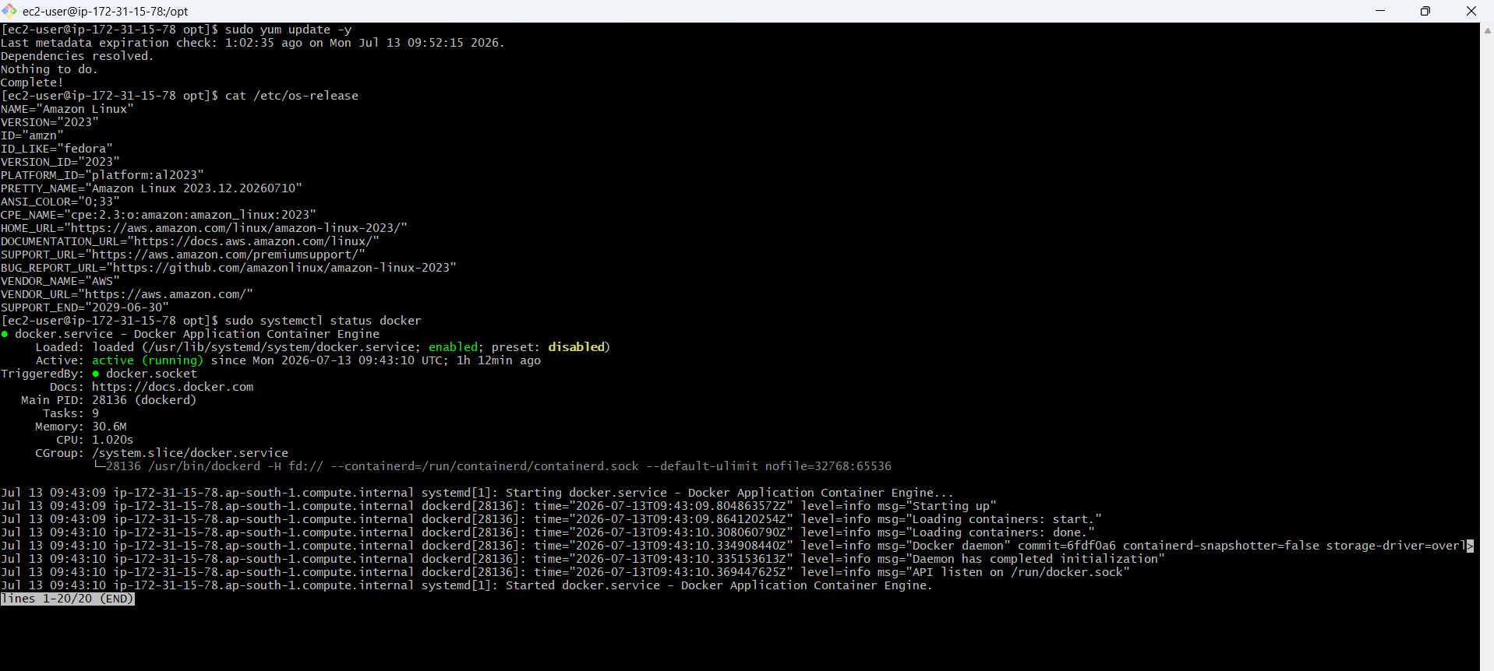
Verify
docker --version
sudo docker ps
4. Install Java
Install Java 21
sudo dnf install java-21-amazon-corretto -y
Configure Java
sudo alternatives --config java
Select Java 21.
Verify
java -version
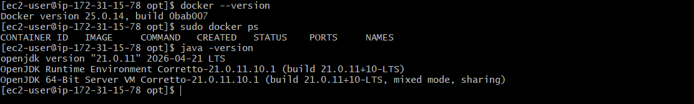
5. Install Jenkins
Add Repository
sudo wget -O /etc/yum.repos.d/jenkins.repo https://pkg.jenkins.io/redhat-stable/jenkins.repo
Import Key
sudo rpm --import https://pkg.jenkins.io/redhat-stable/jenkins.io-2023.key
Install Jenkins
sudo dnf install jenkins -y
Enable Jenkins
sudo systemctl enable jenkins
Start Jenkins
sudo systemctl start jenkins
Check Status
sudo systemctl status jenkins
Get Initial Password
sudo cat /var/lib/jenkins/secrets/initialAdminPassword
Access Jenkins
http://<Public-IP>:8080
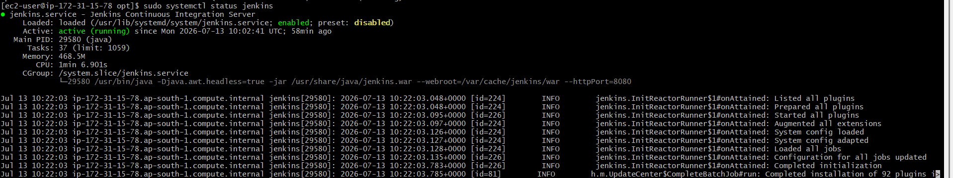
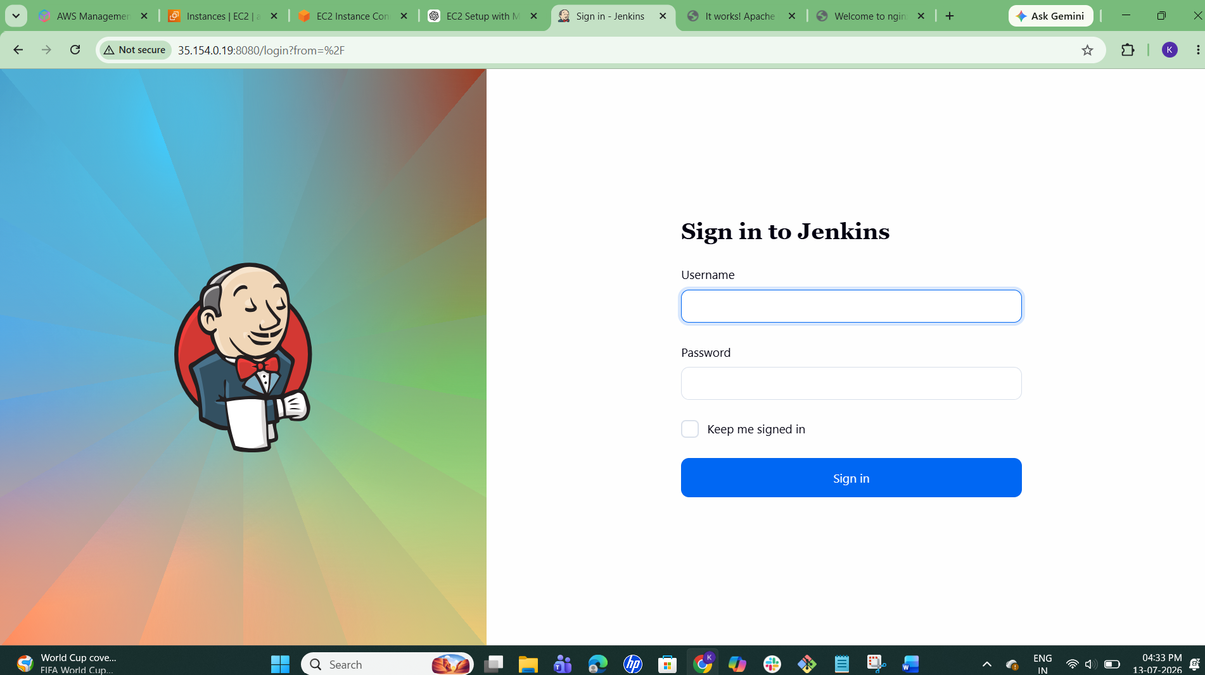
7. Install Apache HTTP Server
Install Apache
sudo dnf install httpd -y
Enable Apache
sudo systemctl enable httpd
Edit Configuration
sudo vi /etc/httpd/conf/httpd.conf
Change
Listen 80
to
Listen 8081
Save
:wq
Restart Apache
sudo systemctl restart httpd
Check Status
sudo systemctl status httpd
Verify
curl http://localhost:8081
Browser
http://<Public-IP>:8081
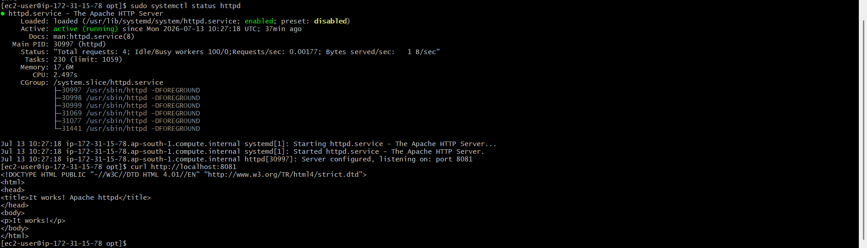
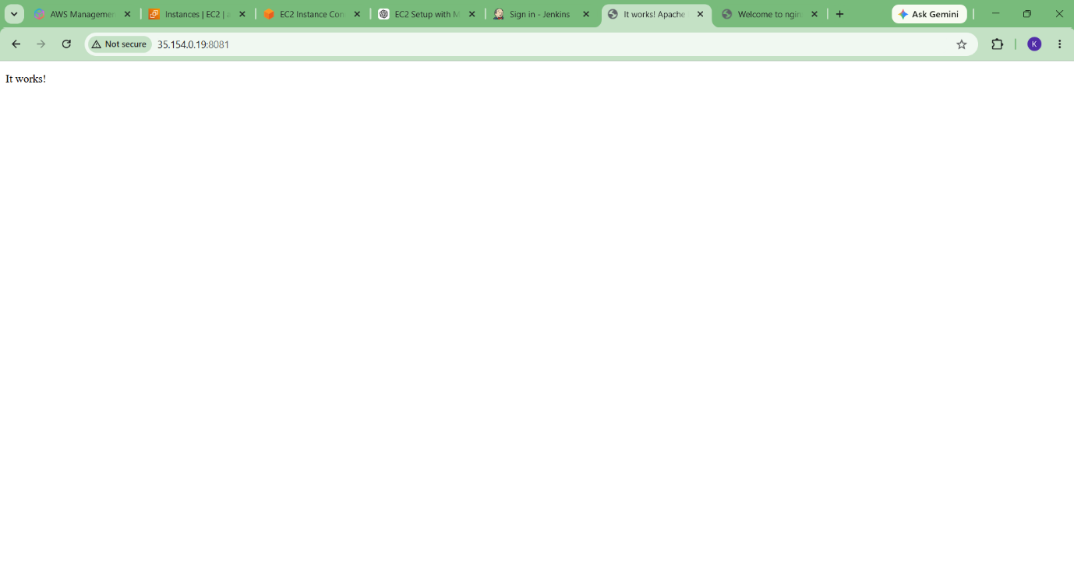
7. Install Nginx
Install
sudo dnf install nginx -y
Enable
sudo systemctl enable nginx
Start
sudo systemctl start nginx
Check Status
sudo systemctl status nginx
Verify
http://<Public-IP>
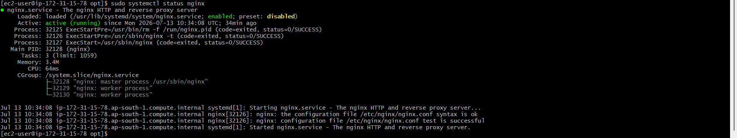
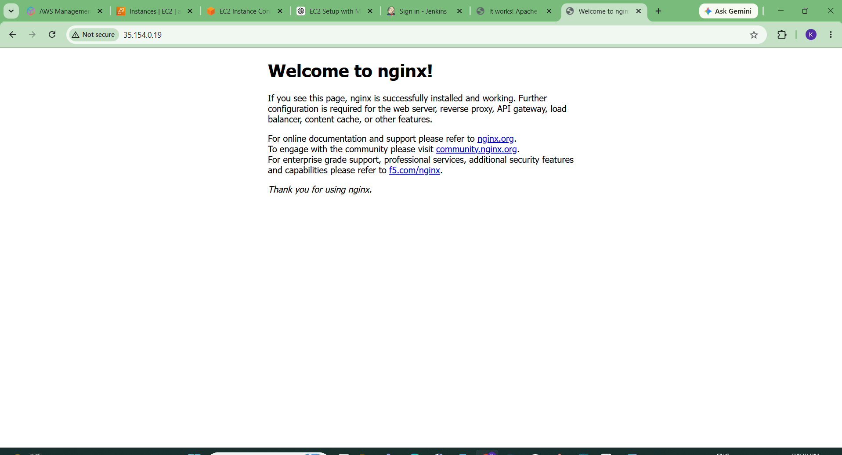
8. Install Apache Tomcat
Download
cd /opt

sudo wget https://archive.apache.org/dist/tomcat/tomcat-9/v9.0.108/bin/apache-tomcat-9.0.108.tar.gz
Extract
sudo tar -xzf apache-tomcat-9.0.108.tar.gz
Rename
sudo mv apache-tomcat-9.0.108 tomcat
Edit Port
sudo vi /opt/tomcat/conf/server.xml
Change
Connector port="8080"
to
Connector port="8082"
Save
:wq
Become Root
sudo -i
Go to Bin Directory
cd /opt/tomcat/bin
Give Permission
chmod +x *.sh
Start Tomcat
./startup.sh
Verify
ps -ef | grep tomcat
or
ss -tulnp | grep 8082
Browser
http://<Public-IP>:8082
